**WIREFRAME DESIGN**

**MUSHROOM CLASSIFICATION**

**By - Prabhjot Singh**

**CONTENTS**

|  |  |  |
| --- | --- | --- |
| **Sr. No.** | **Description** | **Page No.** |
| 1 | Abstract | 3 |
| 2 | Web Interface | 4 |
| 3 | Sample Test Cases | 7 |

1. **Abstract**

Mushrooms hold a timeless significance in human gastronomy, intertwined with both mystery and familiarity. Their name originates from French, linking them to fungi and mold, carrying an air of enigma. Today, mushrooms are valued for their nutrition, low calorie content, and absence of cholesterol, making them popular for health-conscious eaters.

This project introduces an advanced Mushroom Classification Machine Learning Model capable of accurately categorizing mushroom species as either poisonous or edible. Through a meticulously curated dataset and advanced neural networks, the model identifies distinctive patterns for precise classification. Its user-friendly interface accommodates users of all expertise levels, while its adaptability ensures robust performance across various conditions. This innovation not only revolutionizes mushroom classification but also provides a vital tool for mycologists, researchers, and enthusiasts. The report outlines the model's architecture, development, and real-world applicability, highlighting its significant contribution to the field of mycology.

1. **Web Interface**

**App Link -** [**https://prabhjotschugh-mushroom-classification.onrender.com/**](https://prabhjotschugh-mushroom-classification.onrender.com/)

**2.1 Home Page**

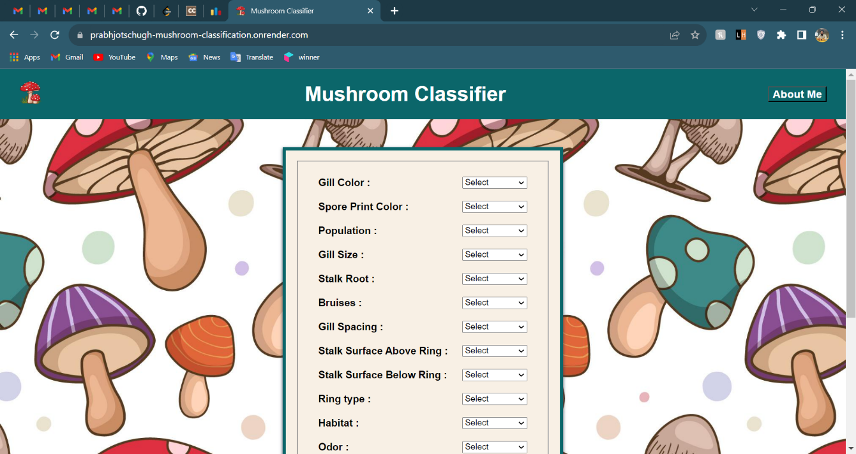When the user clicks on the app link given above, it will direct user to our home page which looks like below:

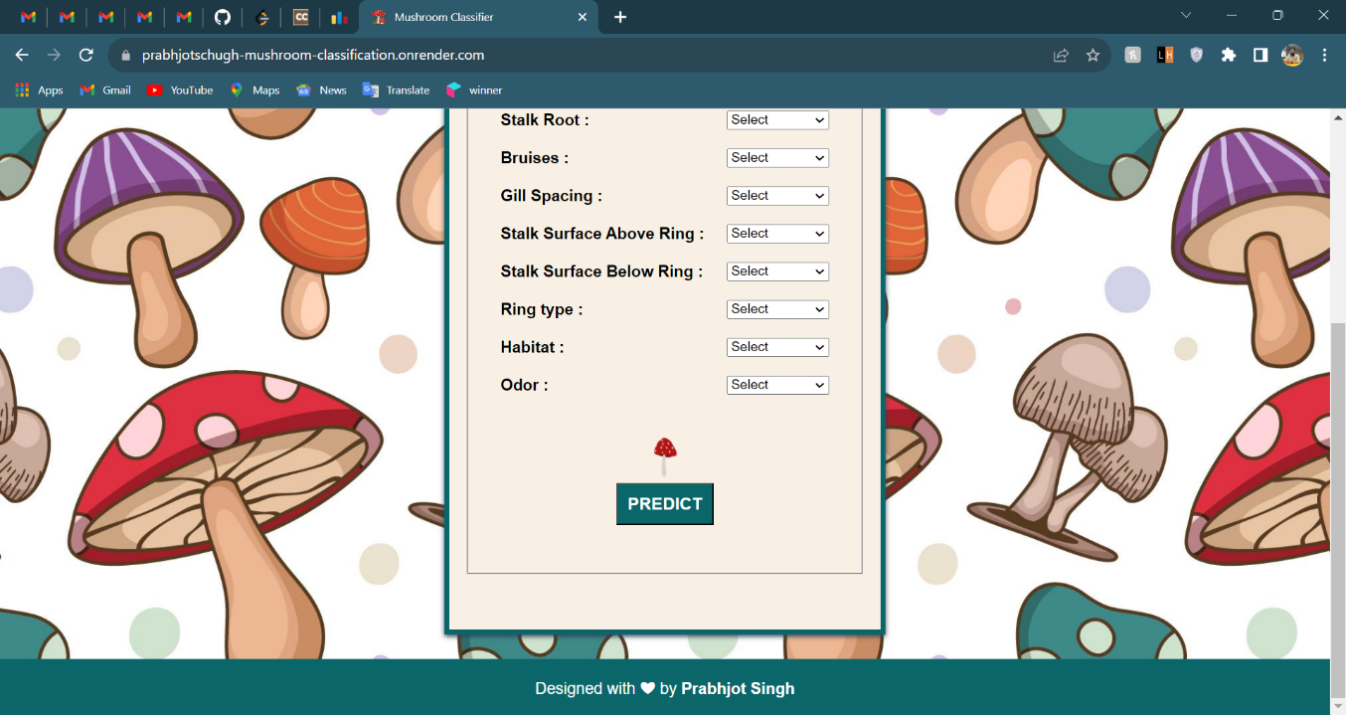

The interface presents a comprehensive set of 12 input fields, each in the form of a dropdown menu. These fields are to be carefully selected based on the specific attributes of the mushroom in question. The purpose of this selection is to determine the mushroom's classification as either edible or poisonous. Upon completing the input, a "Predict" button is provided to initiate the process. This button, when activated, leads the user to a results page that delivers a conclusive verdict on the mushroom's edibility.

The navigation bar features an "About Me" button, which serves as a direct link to my portfolio—a curated collection of my work and accomplishments. Positioned in the footer is my name, designed as a hyperlink that, when clicked, seamlessly redirects the user to my LinkedIn profile. These navigational elements collectively enhance user experience by offering quick access to additional information about me and my professional endeavors.

**2.2 How to use**

As depicted in the aforementioned illustration, the process necessitates the selection of mushroom characteristics through the employment of dropdown menus assigned to individual input fields. These fields encompass the following attributes:

* Cap-Surface
* Bruises
* Gill-Spacing
* Gill-Size
* Gill-Color
* Stalk-Root
* Stalk-Surface-Above-Ring
* Stalk-Surface-Below-Ring
* Ring-Type
* Spore-Print-Color
* Population
* Habitat

Upon meticulous selection of these attributes, the subsequent action entails clicking the "Predict" button. Following this action, the outcome of the prediction process will be promptly exhibited below the "Predict" button. This streamlined user interaction ensures efficient access to the classification result, promptly furnishing insights into the edibility or toxicity of the mushroom based on the specified attributes.

**2.3 Result**

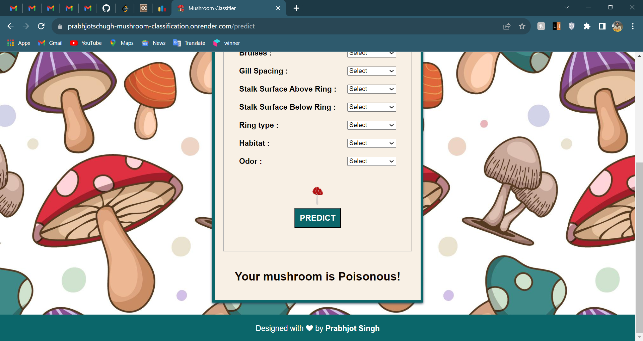

1. **Sample Test Cases**

In each of the ensuing examples, our focus will be directed towards the outputs that emanate from the predictive process. These outputs hold the key to determining the nature of the mushroom's classification – whether it falls under the "Edible" category, rendering it safe for consumption, or the "Poisonous" category, signifying potential harm. The robust predictive algorithm will promptly generate these outcomes based on the selected attributes, offering valuable insights into the nature of the mushroom and facilitating informed decisions about its edibility.

* 1. **Poisonous Mushroom Example**



**3.2 Edible Mushroom Example**

